School of Undergraduate Studies
Social, Behavioral, Mathematical, and Natural Sciences

FINAL EXAMINATION
BIOL 103
INSTRUCTOR NAME:
COURSE NAME: Biology 103
SECTION NUMBER: (Spring2016)
DUE DATE: The answer sheet for this exam MUST be submitted to the Assignment folder within 3 hours of downloading this exam. The final date for submission is 6th March 2016.
SUBMIT ANSWER SHEET to Assignment Folder Final Exam
IMPORTANT: STUDENT PLEASE ANSWER ALL QUESTIONS IN THE ANSWER SHEET DOCUMENT AND SUBMIT THE ANSWER SHEET TO YOUR INSTRUCTOR. FOLLOW ALL INSTRUCTIONS CAREFULLY.
DO **NOT** SUBMIT THIS TEST DOCUMENT FILE TO YOUR INSTRUCTOR.
GENERAL INSTRUCTIONS: This final examination is worth 20% of your overall grade

Read all instructions carefully.

* Do not leave any required questions blank. Make your best guesses.*

**When answering questions for all sections, use the accompanying Answer Sheet. Submit the Answer Sheet document to your Assignment Folder within 3 hours of downloading this document.**
MULTIPLE CHOICE SECTION INSTRUCTIONS: Please answer all questions.

Each question is worth 1 point. Total points for this section is 30 points.

**Do not enter your answers here.** Type in the letter you select as the best answer on the Answer Sheet provided by your instructor.

Use the following information to answer questions 1 and 2 below. ***

Labrador Centronuclear Myopathy (CNM) is genetic disease in Labrador retrievers that results in insufficient muscle function, poor muscles tone, exercise intolerance, and awkward gait. CNM only develops in dogs that are homozygous recessive (pp) for the PTPLA gene. You are a dog breeder and there is one puppy in a new litter that has CNM. Neither of the puppy’s parents have CNM.

- What are the parents’ genotypes for the gene responsible for CNM?
- pp and pp
- Pp and Pp
- PP and PP
- PP and Pp

- Which of the following best describes the mother’s genotype?
- Homozygous recessive
- Heterozygous
- Homozygous dominant
- Heterozygous and Homozygous dominant

- In biological systems most of the original energy from the sun is lost as?
- Light
- Kinetic energy of motion
- Heat
- Potential chemical energy

- All of the following are common or recurrent themes in biology except?
- Organisms grow, develop, and reproduce
- Function determines structure
- Matter is recycled while energy flows through living systems
- Living organisms maintain homeostasis
- Evolutionary processes explain both the unity and adaptive diversity of life

- In the following chemical reaction, what is carbon dioxide (CO₂)?
Organic molecule + 6O₂ ⇨ 6CO₂ + 6H₂O + energy
- independent variable
- product
- substrate
- enzyme
- Which of the following is true regarding chemical bonds?
  - Chemical bonds are an unbreakable union of two atoms
  - Chemical bonds are an energetic interaction, or relationship, that occurs between two atoms
  - Chemical bonds are a physical linkage of two atoms
  - Chemical bonds are the result of energy emitted by radioactive atoms

- The genome of the bacterium, Helicobacter pylori, is composed of 19% guanine. Which of the following must also be true of its double stranded genome?
- 19% cytosine
- 62% adenine
- 31% thymine
- 19% uracil

- You observe the following outside your window: A chipmunk is munching away on a bean plant in your garden when a black rat snake grabs and eats the chipmunk. What is the chipmunk in this situation?
- predator
- primary consumer
- prey
- secondary consumer
- both B and C

9. The template strand of DNA contains the nucleotide base sequence ATGCCA. The nucleotide sequence of the transcribed mRNA strand would be _______________.
- (a) ATGCCA
- (b) ACCGTA
- (c) UACGGU
- (d) TACGGT
- (e) ATCCCT

- The addition of the green fluorescent protein gene from a jellyfish to the genome of the zebra fish in order to produce a fluorescent green colored fish is an example of what?
  - genetic engineering
  - genetic drift
  - evolution
  - selective breeding

- Cellular respiration occurs in which types of cells?
  - Bacterial
  - Animal
  - Plant
  - Protist
  - All of the above

- Dr. Kitty Hauke is studying lobsters in Maine. She noticed that over several years the average length of pincers had increased within this population. She hypothesized that having larger pincers provided a fitness advantage. To test her hypothesis, she introduced 75 large pincer lobsters and 75 small pincer lobsters into an isolated bay area that was similar to the lobsters’ natural sea environment. Over 10 years, Dr. Hauke observed this isolated population of lobsters. What would she likely observe if her hypothesis was incorrect?
  - The percent of lobsters with large pincers would decrease.
  - There were fewer small pincer lobsters mating during mating season.
  - More large pincer lobsters could be found mating during mating season.
  - The percent of lobsters with large pincers would increase.

- Microevolution is to population as macroevolution is to __________.
- Individuals
- Communities
- Biodiversity
- Species

- Active transport requires energy in order to move molecules ____________ the concentration gradient while simple and facilitated diffusion require no energy to move molecules __________ the concentration gradient.
- Along ; against
- Along ; along
- Against ; along
- Against ; against

- Limiting factors:
  - Can be unpredictable natural events
  - Can be both biotic and abiotic
  - Can lead to unlimited population growth
  - A and B
  - A and C
  - B and C
  - All of the above

- Cell is to ________ as gene is to heredity.
  - Organism
  - Organelle
  - Life
  - Biology

- Allopatric speciation involves geography but _________________ speciation involves genetic change.
  - Sympatric
  - Parapatric
  - De novo
  - Peripatric

- A common theme in biology is that energy flows through biological systems while matter __________.
  - Flows
  - Cycles
  - Multiplies
  - Stagnates

- You have discovered a new substance that you suspect may be a living organism. All of the following are characteristics this substance would need in order to be classified as living EXCEPT:
  - Be made of organic molecules
  - Evolve
  - Grow, develop and reproduce with the help of DNA
  - Not contain carbon atoms
  - Use energy and raw materials to survive

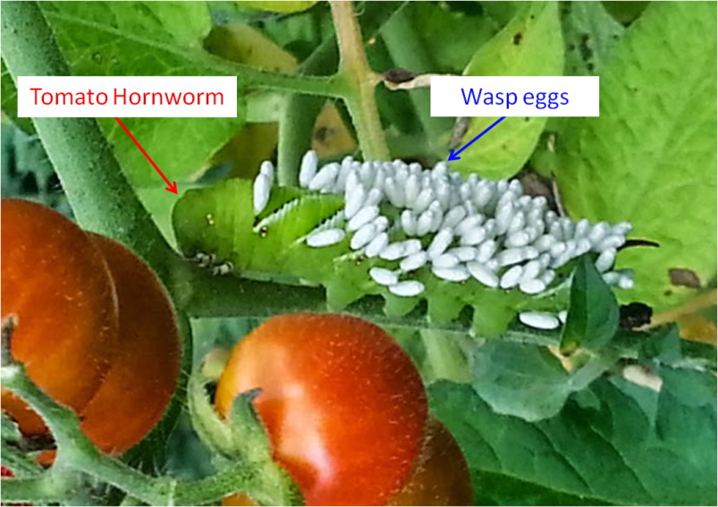
- The following is a picture of a Tomato Hornworm, which is the caterpillar stage of the five-spotted hawkmoth (Manduca quinquemaculata). The white objects protruding from the caterpillar are wasp eggs. The wasps lay their eggs on the horn worms so that when the larvae hatch they can feed on the worm.

Which term best describes the relationship between the wasps and the Tomato hornworms?
  - Mutualism
  - Competition
  - Predation
  - Symbiosis

***Use the following to answer questions 21-24 below. ***
Consider the following hypothetical metabolic pathway (each letter after the word “Molecule” represents a group of atoms):

- What is the reactant for this pathway?
  - Molecule C
  - Molecule COO
  - Molecule COOL
  - Enzyme 1

- What is the intermediate for this pathway?
  - Molecule C
  - Molecule COO
  - Molecule COOL
  - Enzyme 1

- Which of the following best describes this metabolic pathway?
  - The pathway is anabolic
  - The pathway is catabolic

- All of the following would allow for more of the product of this metabolic pathway to be produced, EXCEPT?
  - Increasing the amount of Enzyme 2
  - Increasing the amount of Molecule C
  - Adding an activator for Enzyme 1
  - Adding an inhibitor for Enzyme 1
  - Removing an inhibitor of Enzyme 2

- In Central Dogma: DNA is ________________ into RNA, and RNA is ______________ into proteins.
  - Translated ; transcribed
  - Replicated ; translated
  - Transcribed ; translated
  - Replicated ; transcribed

- What is the genotype for the individual labeled “1” in the pedigree below? (Black circles or squares represent individuals born with a genetic disease such as cystic fibrosis)
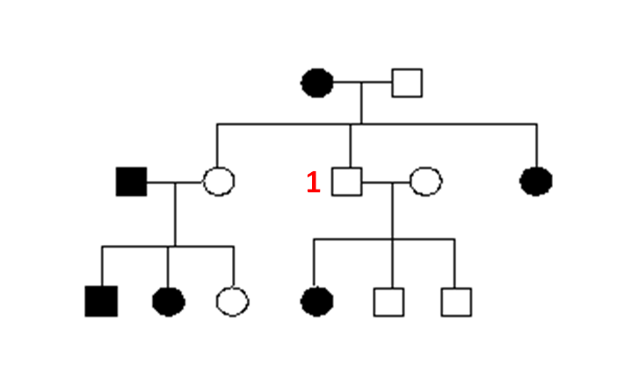
  - AA
  - Aa
  - aa
  - Either AA or Aa

- Which of the following is an example of sexual selection?
  - A diamondback rattlesnake with a color pattern that allows it to blend in better with the desert sand.
  - A farmer cross pollinating two zucchini plants.
  - Male blue-footed boobies dancing to show off their bright blue feet to female blue-footed boobies.
  - A scientist inserting an Escherichia coli gene into the genome of Staphylococcus aureus.

- Consider a rabbit, which of the following is true regarding its DNA?
  - All of its cells contain the same DNA.
  - Each cell type contains its own unique DNA.
  - Rabbit brain cells and kidney cells express the same DNA genes.
  - Rabbit DNA uses a different molecular backbone than mouse DNA.

- Which of the following is the correct order of ecological organizational levels starting from the largest and most inclusive to the smallest and least inclusive?
  - Population > biosphere > community > individual > ecosystem
  - Community > individual > population > biosphere > ecosystem
  - Biosphere > ecosystem > community > population > individual
  - Individual > population > ecosystem > community >biosphere

- You are studying passive diffusion of a molecule called FLUBBER across a semipermeable membrane, which is mimicking the phospholipid bilayer of eukaryotic cells. FLUBBER moves from side A to B. Which of the following can you conclude?
  - Side A had a lower FLUBBER concentration initially compared to side B.
  - Side A had a higher FLUBBER concentration initially compared to side B.
  - Side A had the same initial FLUBBER concentration as side B.

SHORT ANSWER SECTION

Each question is worth 10 points. Total points for this section is 30 points.

Answer THREE out of the five questions listed below. Each answer should be between two paragraphs and half a page long. Answers will be graded for accuracy and completeness, as well as spelling and grammar.

**Do not enter your answers here** Type your answers into the Answer Sheet provided by your instructor.

- At the beginning of the spring, Dr. Allan notices that there is an equal distribution of long and short stemmed buttercups in the vacant lot (which is never cut) across the street from his house, as well as in his own backyard. By the end of the summer he notes that there are mostly long stemmed buttercups in the lot, but mostly short stemmed buttercups in his yard, which he regularly mows. These observations are examples of what biological principle? Develop a hypothesis to explain Dr. Allan’s observations.

- You are analyzing the ingredients in a new hot dog that is going to be put on the market soon. A) Explain the biological function of these natural chemicals that you might find in a hot dog: protein, fat, carbohydrate, vitamins.
B) Would it be healthier to eat a hot dog that contains mainly saturated fat, or one that contains mainly unsaturated fat? Explain your answer.

3. What are mutations? Describe how mutations contribute to variation within a population.
4. Suppose you are taking a cruise from California to Hawaii. About halfway there, the ship begins
to sink. You are able to board a lifeboat, but now you are floating in the ocean waiting to be
rescued. After several days, you are so thirsty that you bend over the side of the boat and drink
lots of salty seawater. Explain what you think will happen to your body within a few hours of
drinking the ocean water, and explain biological basis for your reaction.

- Discuss a specific example of how human activities can damage the environment, and explain how this damage could be reduced or eliminated.

ESSAY SECTION

Answer TWO out of the 5 questions below. Each answer should be approximately one page long. Answers will be graded for accuracy and completeness, as well as spelling and grammar.

Each question is worth 20 points. Total points for this section is 40 points.

**Do not enter your answers here.** Type your answers into the Answer Sheet provided by your instructor.

QUESTIONS

1. Before bringing a new drug to the marketplace, extensive testing is done on the drug by administering the drug to large numbers of individuals. Explain the importance of the scientific method, sample size, controls and variable in the drug evaluation process.

2. List and describe factors that affect the rate of an enzyme reaction

- Consider the food web for the Chesapeake Bay shown below.
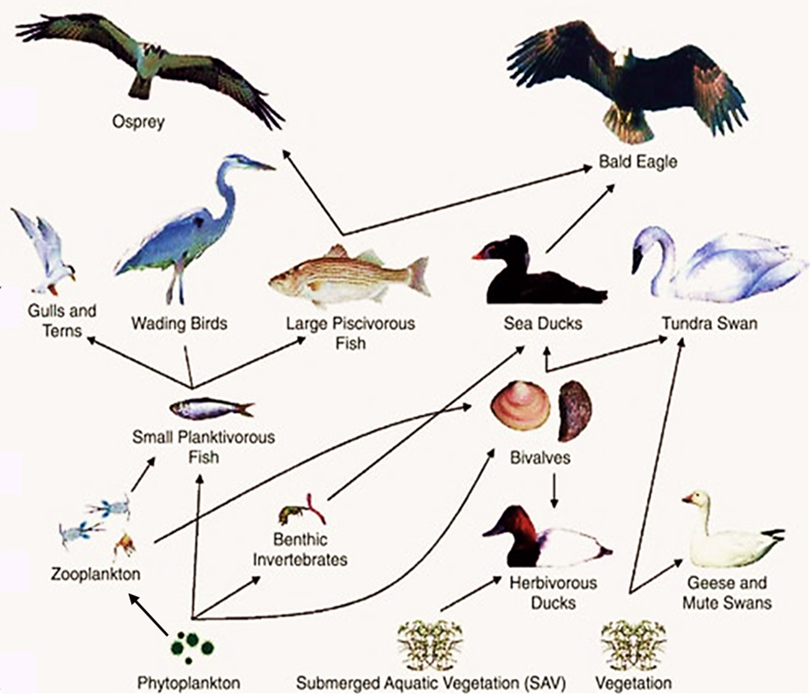
By US Geological Survey (Chesapeake Waterbird Food Web) Public Domain

Give a detailed analysis of this food web. Be sure to address the following in your analysis: a description of the producers and consumers (you do not need to list every organism, but give a few examples along with what makes an organism fall into one class or the other), energy movement through the food web, the number of trophic levels found in this food web, which organisms most efficiently utilize the resources, the way in which of one biogeochemical cycles interacts with the ecosystem of this food web, and how humans can negatively impact this food web.

- Compare and contrast artificial selection (traditional breeding of plants and animals) and genetic modification of organisms (GMOs). In your answer also include the following: two advantages and two disadvantages for each technique, as well as one specific example of each.

- Explain the main stages of mitosis (you may use diagrams) and contrast the processes of mitosis and meiosis in an animal cell.

____________________________________________________________________________

